Extra Problems:
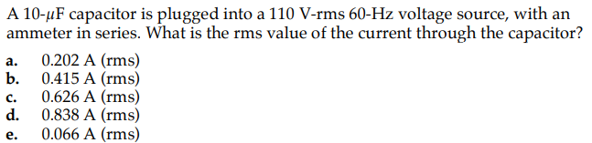

Ans:
b) (solution similar to previous ques).

